Special topics in Computer
Assignment 3

Abasyn University Islamabad

Subject: STIC

Submitted by:
Alishba Malik
Registration No: 9018
Date: November 30, 2025

Submitted to: Sadaf Tanvir

Objectives

1. Explain the Forward Pass

2. Explain Backpropagation

3. Explain Gradient Descent

Task Requirements

You modified the given code using:

Only 1 Conv2D layer

Layers: 1

Epochs: 1

Seed: 1

Dense layer input: 8 × 8 × 32

Conv2D: (8, 8, 2)

Batch size: 32

Image size: 8 × 8

You also created separate folders for each class (Disease & Healthy) in:

TRAIN-1

TEST-1

1. Forward Pass (What Happens When the Image Enters the Network)

A forward pass means sending the input image through the network to produce an output.

Step-by-step Forward Pass in Your Model:

Step 1: Input

Every image is resized to 8 × 8 with 3 channels (RGB)

Input shape: (8, 8, 3)

Step 2: Convolution (Conv2D Layer)

You used:

Filters: 8

Filter size: 3 × 3

Stride: 1

Activation: ReLU

What Convolution Does?

- A 3×3 filter slides over the image.

- 2. At each position:

Multiply filter values with the pixel values.

Add them up (dot product).

Add a bias.

- 3. This produces a feature map.

Why Convolution?

Extracts features such as:

Edges

Texture

Spots

Patterns related to leaf disease

Output of Conv Layer:

Shape becomes (6 × 6 × 8)
(because 8 filters produce 8 feature maps)

Step 3: Activation Function (ReLU)

ReLU(x) = max(0, x)

Purpose of ReLU

Removes negative values

Introduces non-linearity

Helps the network learn complex patterns

Without an activation function, the network behaves like a simple linear model.

Step 4: Max Pooling Layer (2×2)

MaxPooling takes 2×2 blocks and selects the largest value.

Purpose of MaxPooling

1. Reduces image size (Extracts most important values)

2. Removes noise

3. Makes model faster

4. Helps prevent overfitting

Shape after Pooling:

From (6 × 6 × 8) → (3 × 3 × 8)

Step 5: Flatten Layer

Converts 3D values into 1D vector.

(3 × 3 × 8) = 72 neurons

This vector goes into the Dense layer

Step 6: Dense Layers

1. Dense(8) with ReLU

2. Dropout(0.3) to remove overfitting

3. Dense(output_classes) with Softmax

Step 7: Softmax Output Layer

Creates probabilities for each class.

Example:
[0.8, 0.2]
→ 80% Disease, 20% Healthy

2. Loss Calculation (How the Model Knows it is Wrong)

Your loss function:
Sparse Categorical Crossentropy

Crossentropy measures:

How different the predicted probability is from the true label.

Formula:

Loss = – log(predicted probability of correct class)

Example:
Correct class = 1
Model prediction = 0.1
Loss = –log(0.1) = high loss → Model is wrong

If prediction = 0.9
Loss = –log(0.9) = small loss → Model is correct

The training goal:
Reduce this loss value

3. Backpropagation (How the Model Learns)

After loss is calculated, the network starts going backwards.

Backprop Steps:

- 1 Compute derivative of loss with respect to softmax output

- Pass error backward through:

Dense layers

Dropout

Flatten

MaxPooling

Convolution layer

- Compute gradients:

dL/dWeights

dL/dBiases

- Store gradients
- Pass them to the optimizer

What Backprop Actually Does

Finds how much each weight contributed to the error
Adjusts weights in the opposite direction of the error
This is why it is called back propagation of error.

- Gradient Descent (How Weights Are Updated)

Gradient Descent = “Move weights in the direction that reduces loss”.

Update Rule:

new_weight = old_weight – (learning_rate × gradient)

Meaning:

If gradient is large → weight changes more

If gradient is small → weight changes slightly

If gradient is zero → model stops learning

Your model uses Adam optimizer
Adam = advanced Gradient Descent with:

Momentum

Adaptive learning rates

Faster convergence

- How Weights and Biases Are Updated

During Each Batch:

1. Forward pass → compute prediction

2. Compute loss

3. Backpropagation → compute gradients

4. Optimizer updates:

Conv2D weights

Conv2D biases

Dense layer weights

Dense layer biases

Weight update example:

If:

weight = 0.5

gradient = 0.2

learning rate = 0.01

New weight =
0.5 – (0.01 × 0.2)
= 0.498

This is repeated every batch for all layers.

After one epoch, weights have shifted enough to improve prediction.

6. How MaxPooling Backprop Works (Important)

MaxPooling doesn’t have weights.
But it sends gradient only to the maximum value from each pool.

Example:
Pool: [2, 6; 4, 5] → max = 6

In backprop:

Only 6 receives gradient
All other values get zero
This helps keep only the most important fZ|eatures.

Output
Before normalization:

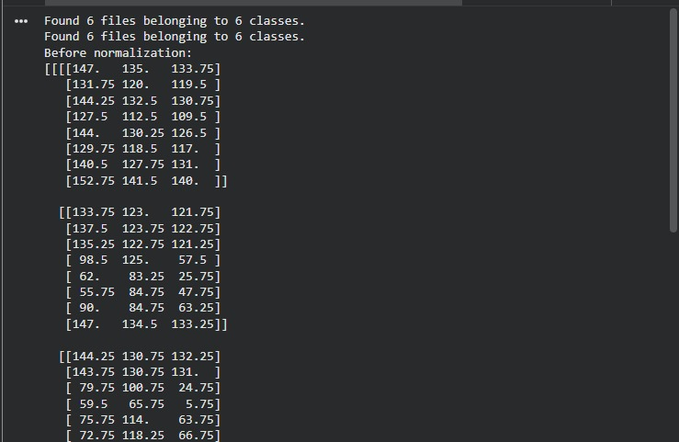

After normalization:
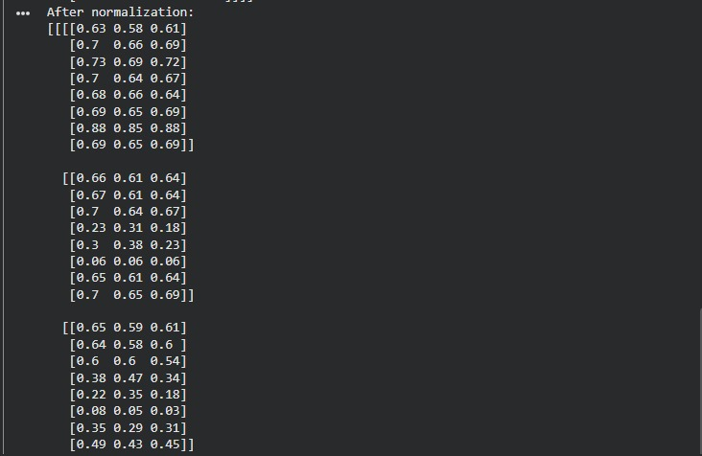

Before training:
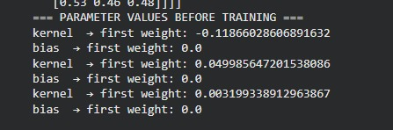

After training:
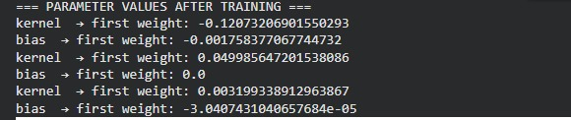

Backward Gradient:
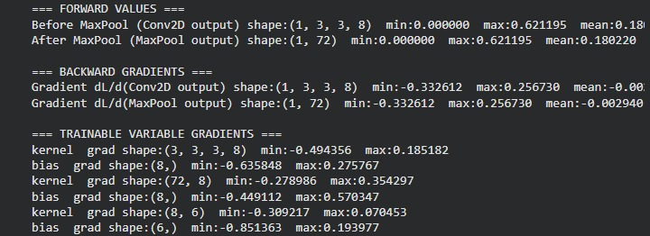
Before maxpooling:

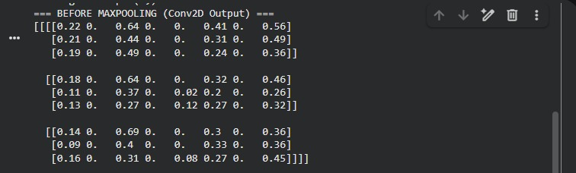

After maxpooling:

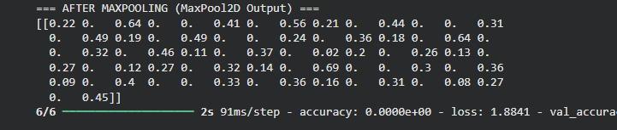
Grapgh:

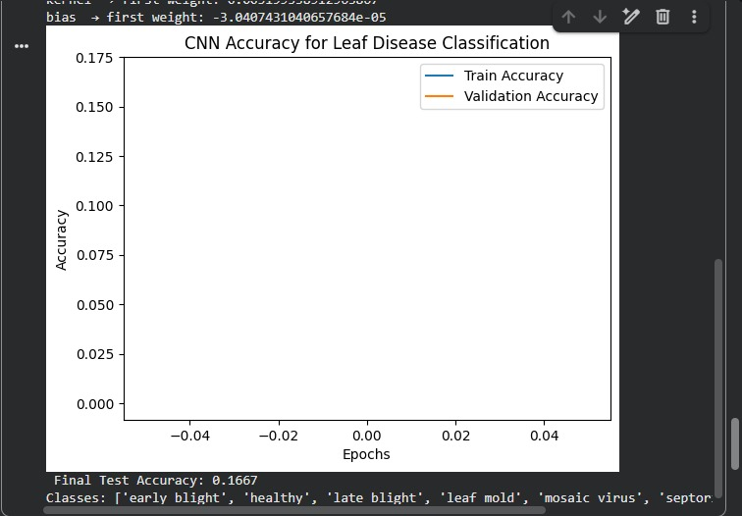

Final accuracy: 0.1667

